|  |  |
| --- | --- |
|  | |
| PROGRAMMING 2B PART 1 | |
| Student Number: | ST10085639 |
| Programme Code: | BCAD2 |
| Module Lecturer: | Courteney Young |
| Module Code: | PROG6212 |
| Date of Submission: | 15-09-2025 |

|  |
| --- |
| I hereby declare that I did not plagiarise the content of this assignment and that this is my own work.  Assignment submitted via Turnitin: a(Tick the Box) |

1. The Documentation:

For the academics who serve as independent contractors (ICs), the Contract Monthly Claim System (CMCS) is an important tool for improving the difficult task of submitting and approving monthly claims (Microsoft, 2023). The CMCS provides you with hands-on training with C# programming and .NET GUI development which bases itself on real-world workplace incidents (Microsoft, 2023).

Bases on its dual purpose as an academic project and a functioning system, CMCS is created to help students improve their software development skills while solving real-world problems at the same time (Microsoft, 2023).

The explanation of design choices:

The User-Centric Design provides easy-to-use navigation and extra features for submitting claims and reviewing them (Emma, 2024) Thus, benefitting academic managers, program coordinators, IC professors and lastly users with disabilities (Emma, 2024). Many user groups can benefit from this design:

* Academic managers (Emma, 2024) .
* The program coordinators (Emma, 2024).
* The lecturers, known as the independent contractors (IC) (Emma, 2024).
* Users that need accessibility (Emma, 2024).
* Security: the system will use encryption to protect sensitive information, especially personal information and finances (Frontegg, 2024). A Role-based access control as well as multi-factor authentication are going to be applied to simply protect user accounts and the claims will be reviewed by the lecturers, program coordinators and the academic management for safety reasons (Frontegg, 2024).

* Scalability and Maintainability: multiple databases that have front-end and back-end features are built into the CMCS system that ensure scalability and maintainability by carrying out easy upgrades and fast integration of new features (Ram, 2023).

The Database Structure:

The relational model that is used in the database supports SQL servers, and it’s supported in .NET systems (Microsoft learn, 2024). The structure includes many important tables:

* Users: this table uses the user’s username, password, user_id and position (Manager, Coordinator or Lecturer) which is stored for system management needs (Microsoft learn, 2024).

* Lecturers: this table uses the lecturer’s ID, first name and surname, hourly rate and the link to the Users table via the user ID (Microsoft learn, 2024). Organized and easy to access lecturer-specific data (Microsoft learn, 2024).

* Claims: this table stores the lecturer claims by creating a connection with the Lecturers database via Claims_id (Microsoft learn, 2024). Given that it has all the lecturer’s data like the month, year, hours worked as well as the status (Submitted, Reviewed, Approved and Rejected) (Microsoft learn, 2024).

* Supporting Documents: the documents correspond to the claim support and is tracked on this table (Microsoft learn, 2024). The foreign Key connects the document to the Claims table and each one is identified by the document_id (Microsoft learn, 2024).

* Approval: this table contains the claim approval information with the approval_id (Microsoft learn, 2024). It contains the approval date; approver comments and the foreign keys connected to the Claims and Users tables (Microsoft learn, 2024).

Assumptions:

* Academic institutions are meant to use the CMCS to handle claims from independent contractors (IC) (Indeed, 2025).
* The lecturers are then paid every month based on the hours they worked (Indeed, 2025).
* Users should have: basic computer skills, relevant to having experience in web applications (Indeed, 2025).
* Before completing the final approval, the claims will be constantly reviewed by the managers and coordinators (Indeed, 2025).

Constraints:

* In order to protect the financial data and the personal data, the system must comply with data protection laws such as the GDPR (Microsoft Security, 2025).
* It must be able to handle large amounts of claims, especially at the end of the month (Microsoft Security, 2025).
* Accessibility needs to be ensured for all users, across all devices, including those with disabilities (Microsoft Security, 2025).
* Users in low-coverage areas have limitations by how much they depend on reliable internet connection (Microsoft Security, 2025).

Conclusion:

The Contract Monthly Claim System (CMCS) improves the administrative process by reducing the handling of claims thanks to it’s simple to use interface (Microsoft learn, 2015). It provides C# development training, improving the students’ skills and tackling real-word problems in the evolving software development sector (Microsoft learn, 2015).

1. The UML Diagram:

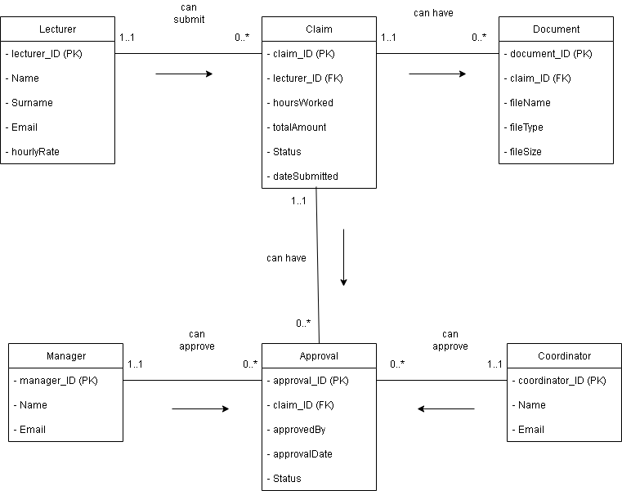

(Microsoft support, 2025)

1. The Project Plan:

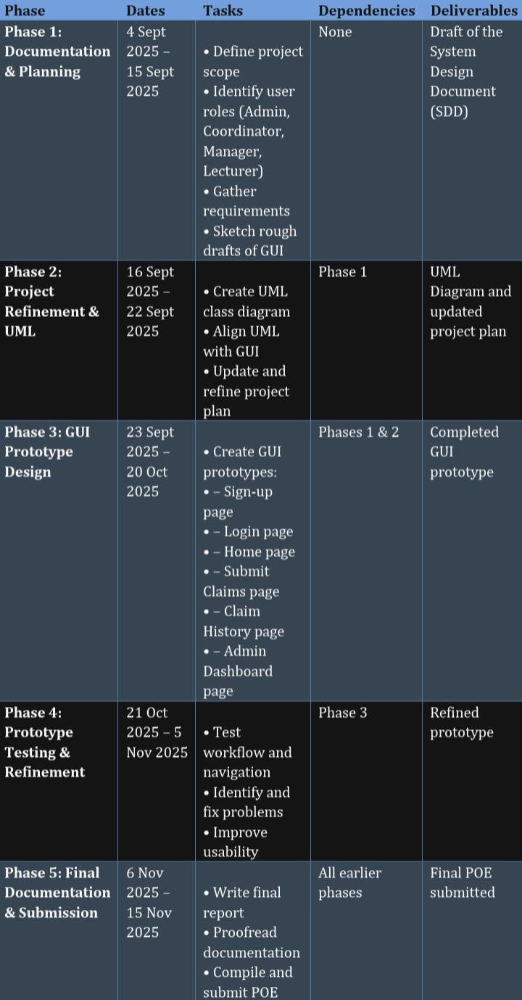

(Awati, 2024)

1. The GUI/UI:

*Figure 1: Sign Up Page*

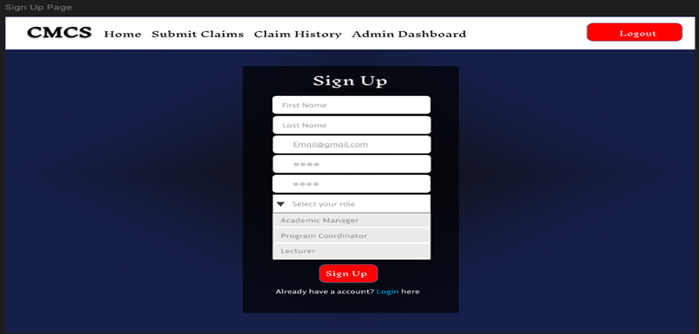

(Figma, 2025)

*Figure 2: Login Page*

(Figma, 2025)

*Figure 3: Home Page*

(Figma, 2025)

*Figure 4: Submit Claims Page*

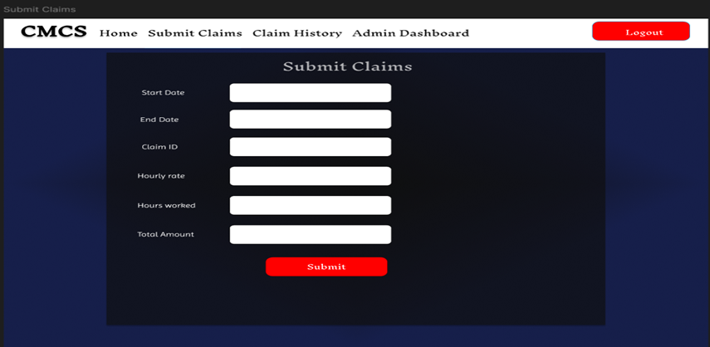

(Figma, 2025)

*Figure 5: Claim History Page*

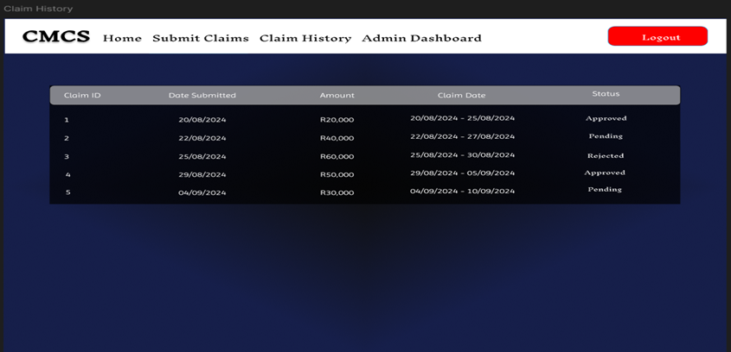

(Figma, 2025)

*Figure 6: Admin Dashboard Page*

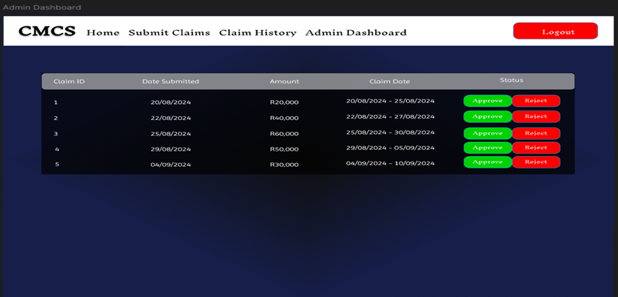

(Figma, 2025)

GitHub Link:

<https://github.com/ST10085639/PROG6212_Part1>

Reference list:

Awati, R. 2024. Project planning: What it is and 5 steps to create a plan, 23 August 2024. [Online], Available at:

<https://www.techtarget.com/searchcio/definition/project-planning>

[Accessed 4 September 2025].

Emma, L. 2024. User-centered design to enhance accessibility and usability

in digital systems, 2 December 2024.

[Online]. Available at:

<https://www.researchgate.net/publication/386339454_User-centered_design_to_enhance_accessibility_and_usability_in_digital_systems>

[Accessed 4 September 2025].

Figma. 2025. Figma, 4 September 2025. [Online]. Available at:

<https://www.figma.com/design/vUmzAj6queQJHisxrIMfvP/CMCS-Part-1?t=oGL0D8tsxlo675ZF-0>

[Accessed 4 September 2025].

Frontegg, 2024. Access Control in Security: Methods and Best Practices, 7 February 2024. [Online]. Available at:

<https://frontegg.com/guides/access-control-in-security>

[Accessed 4 September 2025].

Indeed. 2025. Everything You Need to Know About Majoring in Computer Science, 28 March 2025. [Online]. Available at:

<https://ca.indeed.com/career-advice/career-development/everything-you-need-to-know-about-majoring-in-computer-science>

[Accessed 4 September 2025].

Microsoft learn. 2015. C# Best Practices: Dangers of Violating SOLID Principles in C#, 7 January 2015. [Online]. Available at:

<https://learn.microsoft.com/en-us/archive/msdn-magazine/2014/may/csharp-best-practices-dangers-of-violating-solid-principles-in-csharp>

[Accessed 4 September 2025].

Microsoft. 2023. Claims-based authorization in ASP.NET Core, 11 October 2023.

[Online]. Available at:

<https://learn.microsoft.com/en-us/aspnet/core/security/authorization/claims?view=aspnetcore-9.0>

[Accessed 4 September 2025].

Microsoft learn. 2024. Databases, 22 November 2024. [Online]. Available at:

<https://learn.microsoft.com/en-us/sql/relational-databases/databases/databases?view=sql-server-ver17>

[Accessed 4 September 2025].

Microsoft security. 2025. What is GDPR compliance?, 2025. [Online]. Available at:

<https://www.microsoft.com/en-za/security/business/security-101/what-is-gdpr-compliance>

[Accessed 4 September 2025].

Microsoft support. 2025. Create a UML class diagram, 2025. [Online]. Available at:

<https://support.microsoft.com/en-us/office/create-a-uml-class-diagram-de6be927-8a7b-4a79-ae63-90da8f1a8a6b>

[Accessed 4 September 2025].

Ram, M. 2023. Frontend Development for Scalability: Building Robust and Maintainable Code, 11 July 2023. [Online]. Available at:

<https://medium.com/@mukesh.ram/frontend-development-for-scalability-building-robust-and-maintainable-code-f599425ced03>

[Accessed 4 September 2025].